FAZAIA BILQUIS COLLEGE OF EDUCATION FOR
WOMEN PAF NUR KHAN, RWP
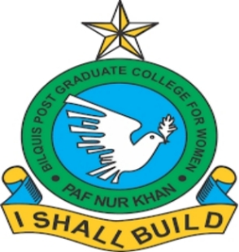
Parallel Distributed Computing (LAB)
Lab 5 Tasks
Submitted to
Ma’am Iffat

Submitted by
Javeria Fazal
BSCS 7th B
F21-62

Task 1
Develop a simple Client–Server application in C# using socket programming where the client sends a number to the server, and the server computes and sends back the table for that number.
- Source Code with Output Screenshot:
- Server Side:
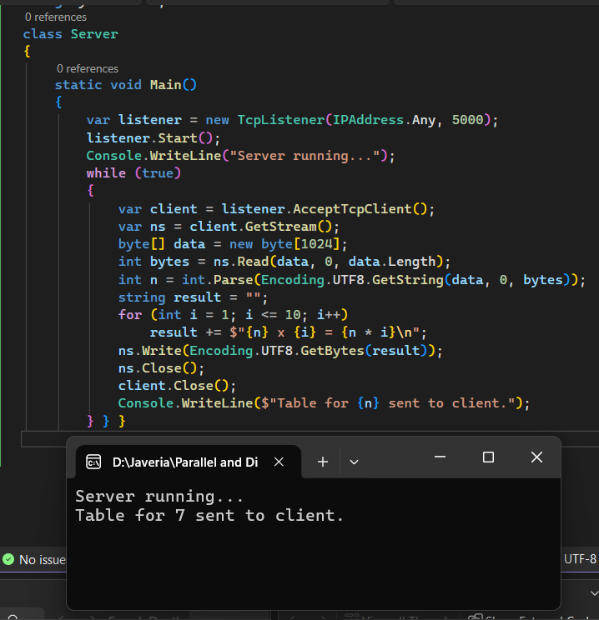
Figure 1: Server Side with Output
- Client Side:
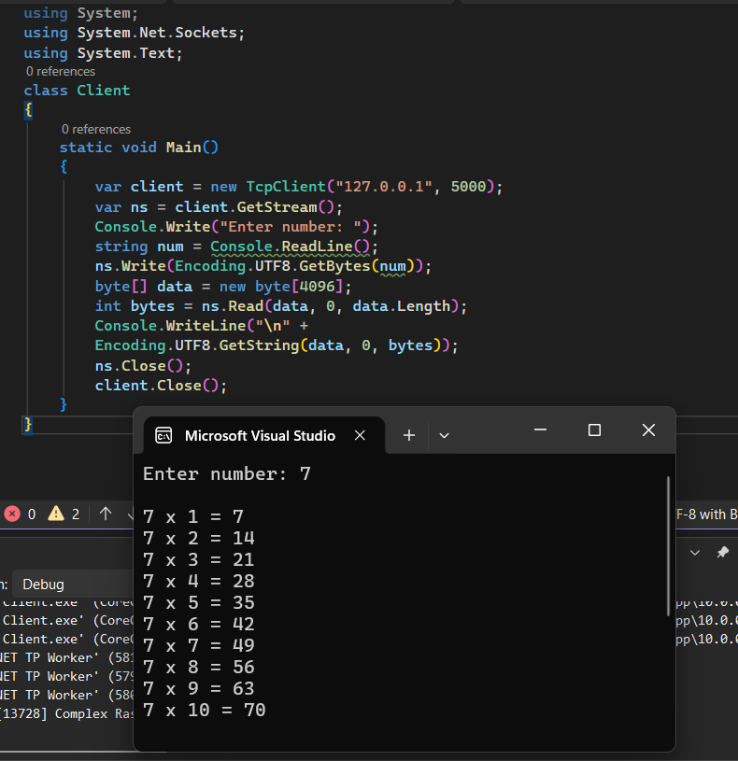
Figure 2: Client Side with Output
Task 2:
Design a Client–Server application in C# that performs file transfer over sockets using binary streams.
1. The client will request a file by its name, and the server will locate the requested file, read it in binary format, and send it back through the network.
2. The client will then receive the file data and save it locally under the same file name.
- Source Code with Output:
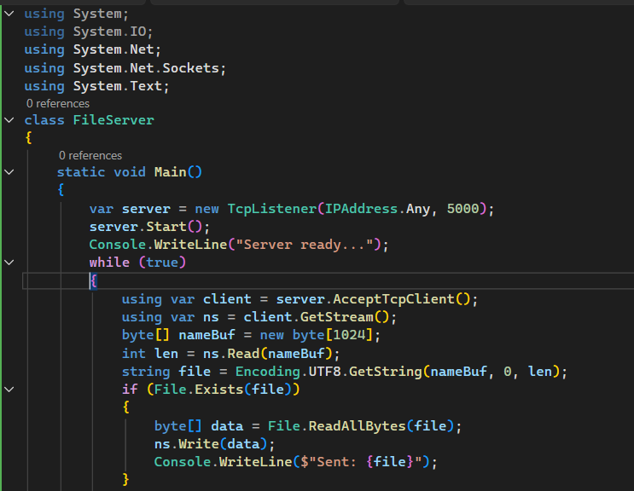
- Server Side:
Figure 3: Server side
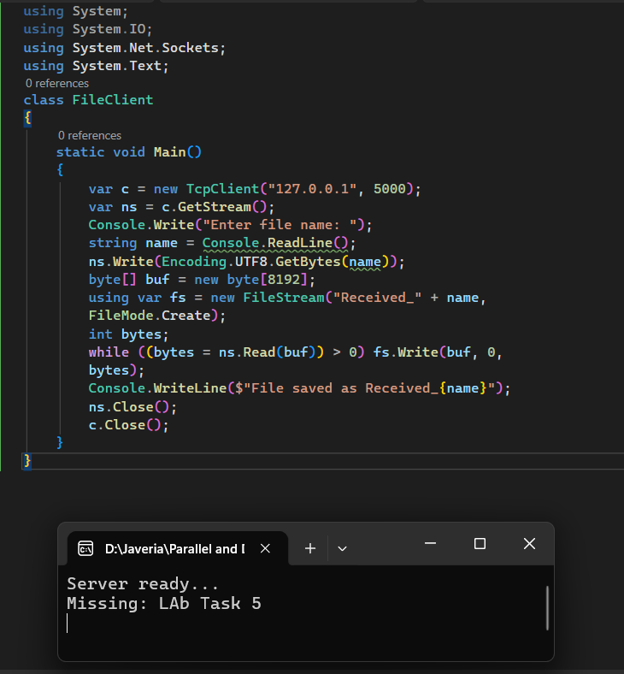
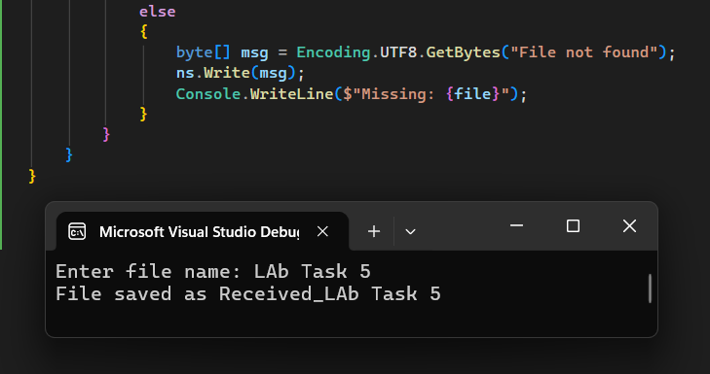
- Client Side:
Figure 4: Server Side with Output (Cont.)
Figure 5: Client Side with Output
Task 3:
Design a Client–Server application in C# using TCP sockets that performs user authentication over a network.
1. The client sends a username and password to the server, which validates the credentials against a predefined list.
2. If the credentials match, the server sends back "Login Successful", otherwise "Invalid Credentials".
- Source Code with Output:
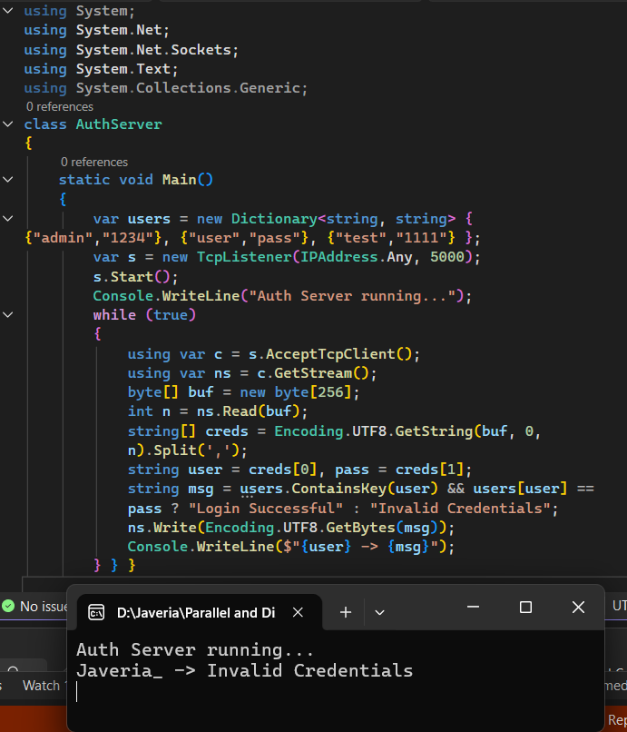
- Server Side:
Figure 6: Server Side with Output
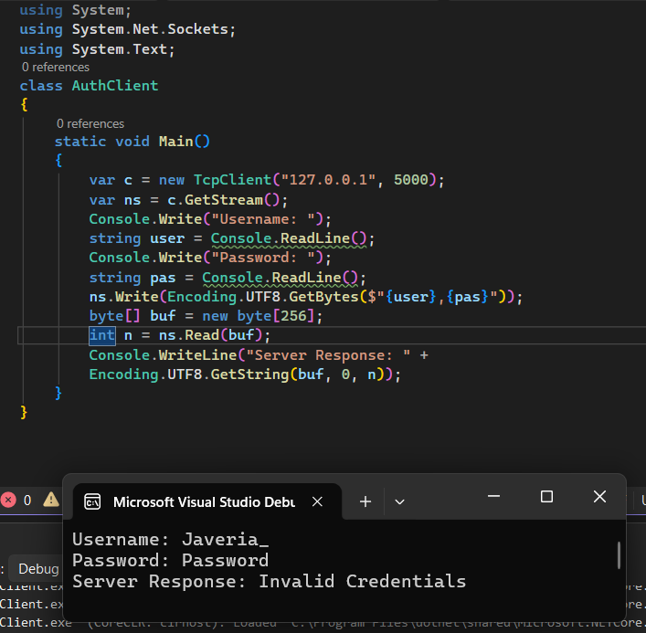
- Client Side:
Figure 7: Client Side with Output

